Revealed: How eco-friendly Brits will be when travelling abroad this summer

- Most Brits will seek to walk, bike or use public transport (78%) to explore their holiday destination – thus, not creating additional carbon emissions from hiring a private vehicle
- Thereafter, 75% are going to take re-usable bags with them instead of accepting single-use plastic carrier bags offered to them
- Holidaymakers would ideally like hotels to save energy by enabling features such as TV, lights and air conditioning (82%) to only work when they are in the room
- Subsequently, 70% don’t mind if toiletries in their hotel bathroom are replaced less frequently
- Interestingly, 67% believe hotels should take the initiative to include a recyclable as well as non-recyclable bin in all their rooms

The summer holidays are nearly upon us and thousands of Brits across the country will flock abroad for a much-needed vacation.
With a holiday abroad providing an opportunity to live more extravagantly compared to when at home (e.g. taking longer showers, getting fresh towels every day etc.), it can blur the lines between indulgence and wastage. Given the alarming environmental issues facing the world, how concerned are Brits about the environmental impact they leave behind when they go on holiday overseas?
Interested in holidaymakers’ eco-intentions, Taxi2Airport.com surveyed 1,468 Brits who have booked a trip abroad this summer to discover how eco-friendly they plan to be with regards to a range aspects concerning their holiday experience.
Taxi2Airport found that most Brits will seek to walk, bike or use public transport (78%) to explore their holiday destination. In doing so, avoiding the additional carbon emissions they would create from taking the alternative option of hiring a private vehicle (e.g. rental car etc.)
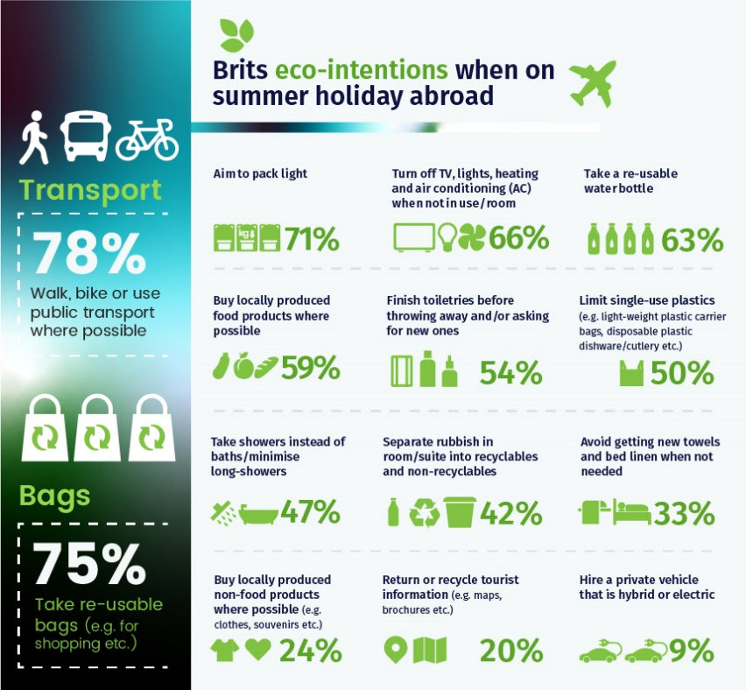
Thereafter, 75% are going to take re-usable bags with them. Especially handy when shopping and a much better option than accepting the single-use plastic carrier bags offered to them – which cause significant damage to the environment.
In third position, 71% have a strong desire to pack as light as possible. In turn, this will have an indirect positive effect on their flight, because if a plane weighs less – it increases fuel-efficiency and decreases the carbon emissions it produces. Slightly below, 66% state they will make a conscious effort to turn off the TV, lights, heating and air conditioning (AC) when not in use or present in the room.
Interestingly, since toiletries such as toothpaste, shower gels and shampoos are provided on a complimentary bases in a majority of hotels – it can be easy to use them wastefully as they are ‘free’. Bearing this in mind, 54% will only throw away and/or ask for new toiletries once they have finished their existing set.
Contrastingly, a mere 9% of travellers with ambitions to hire a private vehicle, are going to make sure their selection is either a hybrid or electric model. Just above, 20% will commendably recycle or return any tourist information (e.g. maps, brochures etc.) they accumulate from their ventures – with the latter, allowing other tourists/visitors to re-use them.
Furthermore, Taxi2Airport sought to find out the ways in which Brits think hotels (domestically as well as internationally) can become eco-friendlier.
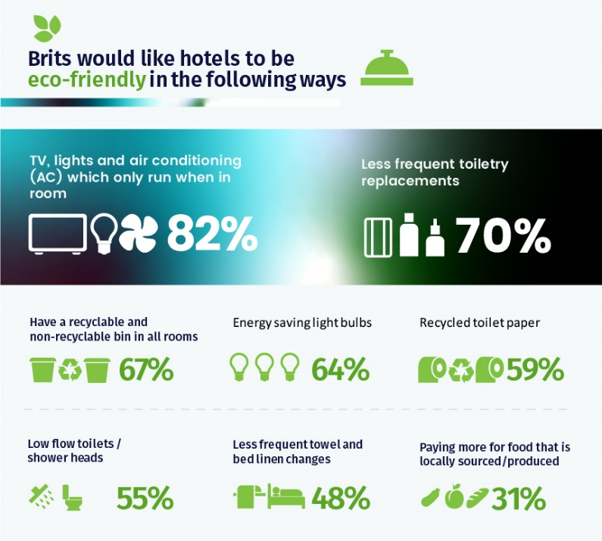
Taxi2Aiport found that Brits would ideally like hotels to save energy by enabling features such as TV, lights and air conditioning (82%) to only work when they are present in the room. Subsequently, 70% don’t mind if toiletries in their hotel bathroom are replaced/replenished less frequently.
Fascinatingly, 67% believe hotels should take the initiative to include a recyclable as well as non-recyclable bin, so they can separate any rubbish in their room between the two. Surprisingly, a sizeable 55% of travellers would be happy if their hotel bathroom had a low flow shower head and toilet – both going a long way towards reducing water consumption.
On the other end, 31% would be satisfied paying more for food in the hotel, knowing the ingredients have been locally produced/sourced. Whilst, 48% have no issue if hotels were to replace towels and bed linen fewer times rather than doing so on a daily schedule.
Overall, an overwhelming 76% of British holidaymakers feel hotels can play a much bigger role than they currently are in being ‘greener’.
Yoon Sterkenburg, the Co-Founder of Taxi2Airport.com commented:
“Among the relaxation and fun when abroad, it can be easy for holidaymakers to forget the eco-habits they typically practise at home such as recycling and not wasting electricity. Despite this, as the reporting and occurrence of environmental problems increases, more and more individuals are becoming aware of the small role they can play to save the planet. This includes the steps they can take when travelling overseas. This research certainly shows that Brits have varying ways in which they intend to be environmentally-friendly when abroad this summer. Regardless of how small or big, if enough travellers carry out these actions - the impact can be very beneficial and contribute towards improved sustainability in the country they are visiting”.
Notes to editor: Please note, if you use any of this press release and/or infographics, please credit https://www.taxi2airport.com/en

