- Login to email (always use roundcube as is easiest) and find PR post (either written as part of email or as Word/PDF document)
Screenshot of word document within email containing post
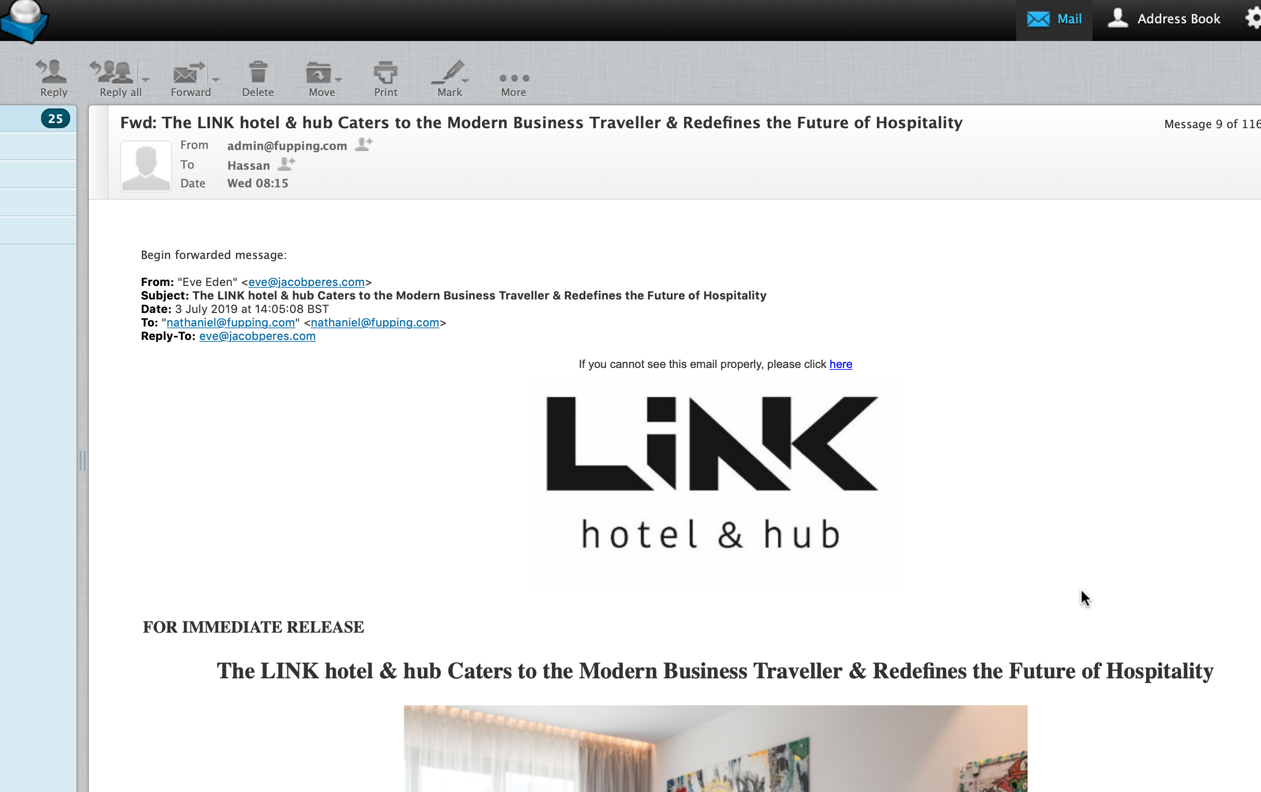
Screenshot of article written as an email.

- Decide what website PR post is most suitable to post e.g Lifney = Travel/world etc.
- Login to Website following (www.XX.com/wp-admin) and click “New post” tab
- If word Document, download the word document and use “mammoth .docx converter” to upload word documents and then click “insert into editor”.
- If an article is written as part of the email copy and paste article into editor making sure it is only the article being copied and pasted. Stop before the “ends” and do not include original emails. Always copy the pictures across aswell.

- Using the following link (https://titlecase.com) copy and paste title into “Enter text below” and then click “convert”. Then scroll down to “AP- style title case” and copy the text.
Screenshot of Title converted using https://titlecase.com.
- Copy this title into the title section making sure the permalink is also the same as the title.
Screenshot of title and permalink
- Format the article making sure nothing is “block quoted” and all titles are
“heading 2” from dropdown and all quotes are “block quoted”. Make sure all pictures are always centred.
Block Quote
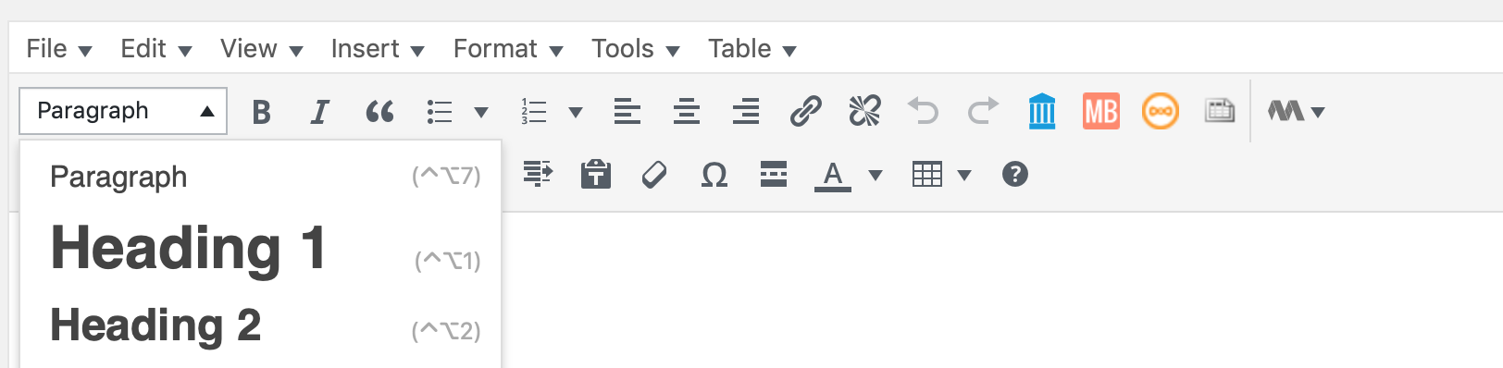
- if no pictures within article choose a suitable picture from the following link (https://unsplash.com). Whilst here also choose a cover image for the article. When downloading a photo always copy the credit.

- Then “upload” relevant pictures into article via “add media” when added paste the copied credit into each section/ descriptions of the photo as seen below:

- Always re size image but clickling “edit image” and make bigger value 2000. This must always be done.
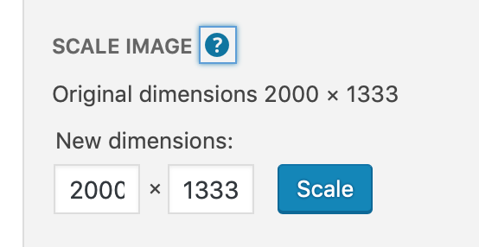
- When inserting image into article make sure it is centred and full sized by editing photo after it has been inserted into text.
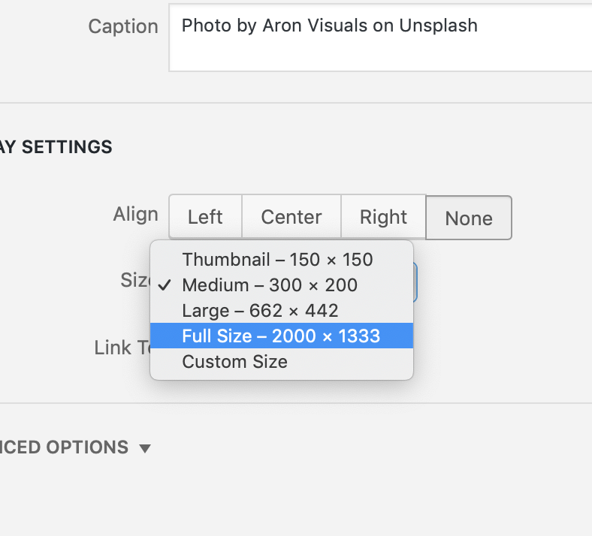
- Then add relevant tags to summarise the article. E.g. if article is about a holiday to a country make tags –“Country Name” and “Summer” if the country is hot and reminds you off summer.
- Assign the title a category in the category section.
- Make sure if required the template used is always:
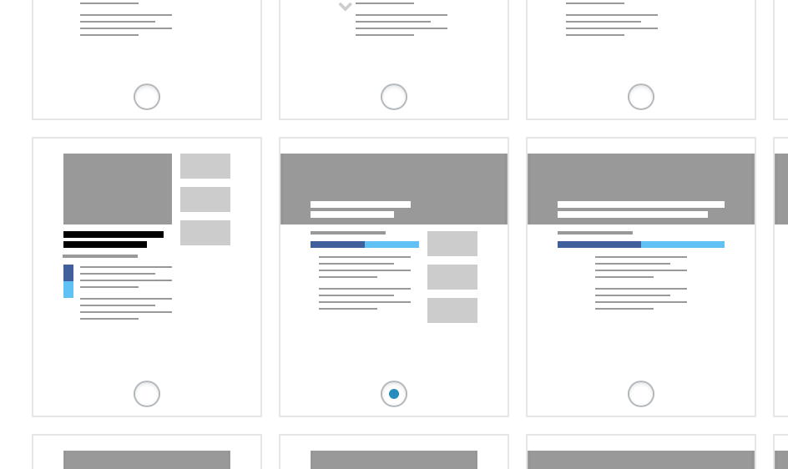
- Then save to draft.
- Make a spread sheet in excel/google docs where you must put the date, “from” email and article title which will be checked every night.
- Then reply to email by copying “from” email into “to” and using the template below:

Hey,

I posted this article, it can be found here: https://fupping.com/hassanahmed/2019/06/06/the-multi-5-in-1-scissors-that-can-do-everything/.

We would love for you to share and post this on your social media platforms as it is mutually beneficial.

Thanks,

- Finished and move onto next article. ALWAYS make sure to complete step 17.

